# **Practical : Webot Simulator Line follower**

# Development Overview



# Simulator : Setup Simulator

Go to <https://cyberbotics.com/>

Download webot installation. Then install program

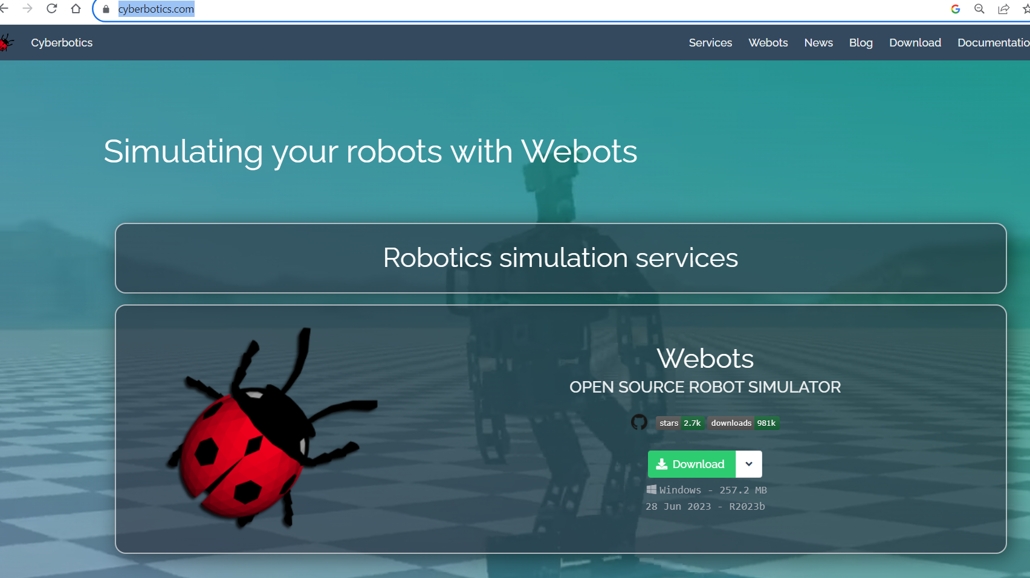

https://github.com/IuAyala/Self-Driving-Cars-Course#windows

**Install Webots - Windows**

**Download the latest version of Webots (i.e. webots-R2023b_setup.exe) from the official website**

**Double click on this file**

**Follow the installation instructions**

**Manual Installation - Windows**

**Install:**

**Python(tested with python 3.11)**

**Make sure you tick "Add Python 3.X to PATH"**

**pip3 install -r requirements.txt**

**Set the required environment variables**

**Click the "Windows Key" and write "Edit the system environment variables"**

**Create variable “WEBOTS_HOME” with content “C:\Program Files\Webots”**

**Create variable “PYTHONPATH” with content “%WEBOTS_HOME%/lib/controller/python”**

**Add to “PATH”**

**“%WEBOTS_HOME%\lib\controller”**

**“%WEBOTS_HOME%\msys64\mingw64\bin”**

**“%WEBOTS_HOME%\msys64\mingw64\bin\cpp”**

**Create variable “PYTHONIOENCODING” with content “UTF-8”**

**Run Webot program**

**At File>Open World..>city.wbt**

1. Run the simulator

Run Webot with city.wbt simulation environment

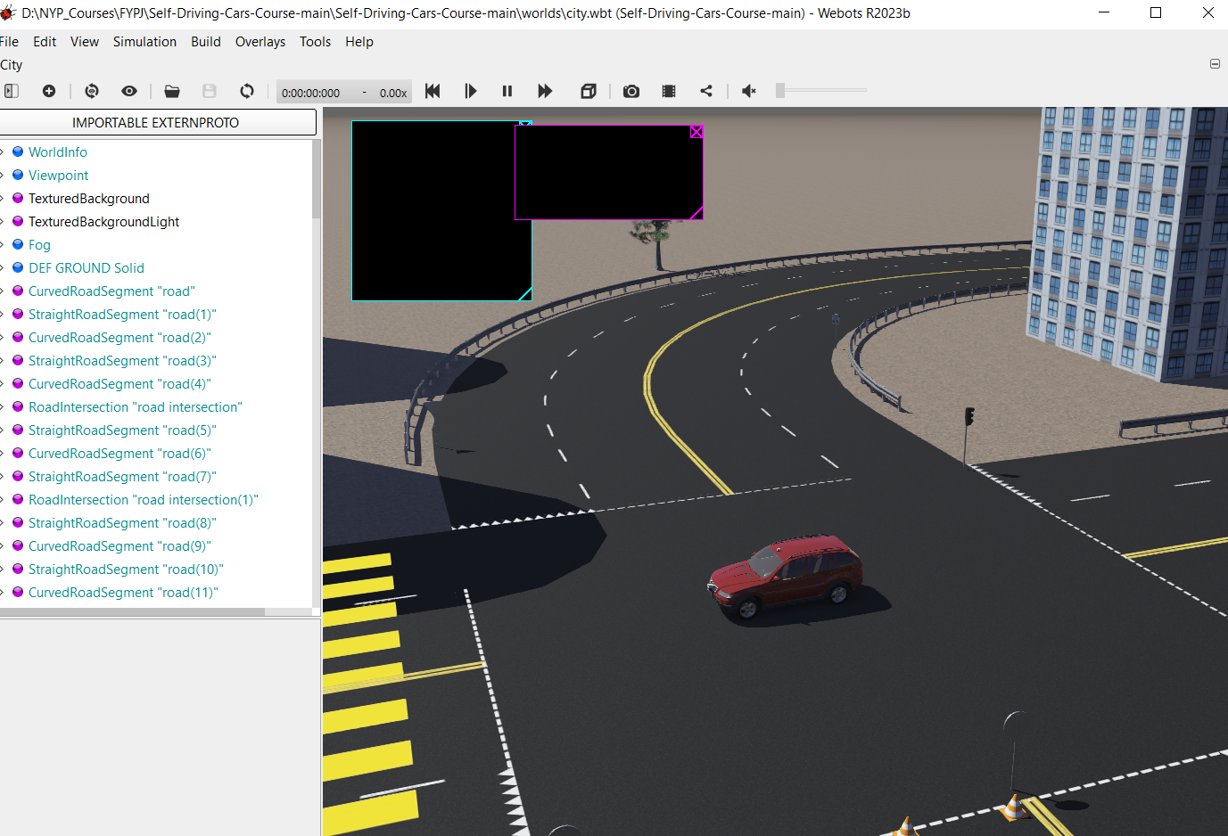

1. Run the 1_create_dataset.py in the python virtual environment

Navigate the car to follow the yellow line.

1. Run 2_train.py to train the model.

A train model with extension .h5 will be produced after training

1. Run 3_run_model.py to perform autonomous car driving in the simulator

# Part 2: Model Development

## **Section 1: Create Deep learning model for training**

1. Use ***2_create_model.ipynb*** to create a CNN model for training(in laptop)

Note: This is not the Jupyter Notebook from the Jetbot.

1. Complete the training to save trained model into the mode.tflite